**PATFIN NURSERY AND PRIMARY SCHOOL, AKESAN, LAGOS STATE.**

**THIRD TERM EXAMINATION [ 2017 / 2018 ]**

**CLASS : HEAD – START**

**NAME : _____________________________________________ SUBJECT: SCIENCE**

**INSTRUCTION : ANSWER CORRECTLY DURATION : 1 HOUR**

1. Mention three(3) things we need in the kitchen
2. _______________________, (b) ____________________ , (c) ________________________ .
3. Pot is used for __________________ [ Cooking / Dancing ]
4. Mention three(3) things in the sitting room
5. ______________________ , (b) ____________________, (c) ________________________ .
6. Mention three(3) things in the school
7. _____________________ , (b) _______________________, (c) _________________________ .
8. Name three(3) kinds of animals you know
9. ______________________ , (b) _______________________, (c) __________________________ .

**PATFIN NURSERY AND PRIMARY SCHOOL, AKESAN, LAGOS STATE.**

**THIRD TERM EXAMINATION [ 2017 / 2018 ]**

**CLASS : HEAD – START**

**NAME : _____________________________________________ SUBJECT: SCIENCE**

**INSTRUCTION : ANSWER CORRECTLY DURATION : 1 HOUR**

1. Mention three(3) things we need in the kitchen
2. _______________________, (b) ____________________ , (c) ________________________ .
3. Pot is used for __________________ [ Cooking / Dancing ]
4. Mention three(3) things in the sitting room
5. ______________________ , (b) ____________________, (c) ________________________ .
6. Mention three(3) things in the school
7. _____________________ , (b) _______________________, (c) _________________________ .
8. Name three(3) kinds of animals you know
9. ______________________ , (b) _______________________, (c) __________________________

**PATFIN NURSERY AND PRIMARY SCHOOL, AKESAN, LAGOS STATE.**

**THIRD TERM EXAMINATION [ 2017 / 2018 ]**

**CLASS : HEAD – START**

**NAME : _____________________________________________ SUBJECT: SOCIAL – HABITS**

**INSTRUCTION : ANSWER CORRECTLY DURATION : 1 HOUR**

1. We must always say thank you to our parents [ Yes / No ]
2. If someone gives me a gift, I must say “Thank You ” [ Yes / No ]
3. Should you be rude to visitors? [ Yes / No ]
4. Is stealing a good habit? [ Yes / No ]
5. A good child must not eat another person’s food. [ Yes / No ]
6. I must always tell the truth [ Yes / No ]
7. What is Obedience? ___________________________________________________________________________.
8. What is kindness? _____________________________________________________________________________
9. Is it good to shout at your parents? [ Yes / No ]
10. Is it good too fight everybody? [ Yes / No ]

**PATFIN NURSERY AND PRIMARY SCHOOL, AKESAN, LAGOS STATE.**

**THIRD TERM EXAMINATION [ 2017 / 2018 ]**

**CLASS : HEAD – START**

**NAME : _____________________________________________ SUBJECT: SOCIAL – HABITS**

**INSTRUCTION : ANSWER CORRECTLY DURATION : 1 HOUR**

1. We must always say thank you to our parents [ Yes / No ]
2. If someone gives me a gift, I must say “Thank You ” [ Yes / No ]
3. Should you be rude to visitors? [ Yes / No ]
4. Is stealing a good habit? [ Yes / No ]
5. A good child must not eat another person’s food. [ Yes / No ]
6. I must always tell the truth [ Yes / No ]
7. What is Obedience? ___________________________________________________________________________.
8. What is kindness? _____________________________________________________________________________
9. Is it good to shout at your parents? [ Yes / No ]
10. Is it good too fight everybody? [ Yes / No ]

**PATFIN NURSERY AND PRIMARY SCHOOL, AKESAN, LAGOS STATE.**

**THIRD TERM EXAMINATION [ 2017 / 2018 ]**

**CLASS : HEAD – START**

**NAME : _____________________________________________ SUBJECT: HEALTH – HABITS**

**INSTRUCTION : ANSWER CORRECTLY DURATION : 1 HOUR**

1. Cough is a common illness children have. [ Yes / No ]
2. I must wash my hands to avoid germs [ Yes / No ]
3. Mention three(3) items in the first – aid box
4. ________________________
5. ___________________________
6. ________________________________
7. When you touch hot water, how do you feel? [ Hot / Cold ]
8. I must not litter the floor [ Yes / No ]

**PATFIN NURSERY AND PRIMARY SCHOOL, AKESAN, LAGOS STATE.**

**THIRD TERM EXAMINATION [ 2017 / 2018 ]**

**CLASS : HEAD – START**

**NAME : _____________________________________________ SUBJECT: HEALTH – HABITS**

**INSTRUCTION : ANSWER CORRECTLY DURATION : 1 HOUR**

1. Cough is a common illness children have. [ Yes / No ]
2. I must wash my hands to avoid germs . [ Yes / No ]
3. Mention three(3) items in the first – aid box
4. ________________________
5. ___________________________
6. ________________________________
7. When you touch hot water, how do you feel? [ Hot / Cold ]
8. I must not litter the floor [ Yes / No ]

**PATFIN NURSERY AND PRIMARY SCHOOL, AKESAN, LAGOS STATE.**

**THIRD TERM EXAMINATION [ 2017 / 2018 ]**

**CLASS : HEAD – START**

**NAME : __________________________________________ SUBJECT: CHRISTAIN RELIGIOUS STUDIES**

**INSTRUCTION : ANSWER CORRECTLY DURATION : 1 HOUR**

1. Who is God?

_______________________________________________________________________________

1. Mention three(3) disciples of Jesus
2. __________________
3. _____________________
4. ________________________
5. What is Love?

__________________________________________________________________________________

1. Jesus turned _________ into wine . [ Sand / Water ]
2. Is it good to tell lies ? [ Yes / No ]

**PATFIN NURSERY AND PRIMARY SCHOOL, AKESAN, LAGOS STATE.**

**THIRD TERM EXAMINATION [ 2017 / 2018 ]**

**CLASS : HEAD – START**

**NAME : __________________________________________ SUBJECT: CHRISTAIN RELIGIOUS STUDIES**

**INSTRUCTION : ANSWER CORRECTLY DURATION : 1 HOUR**

1. Who is God?

_______________________________________________________________________________

1. Mention three(3) disciples of Jesus
2. __________________
3. _____________________
4. ________________________
5. What is Love?

__________________________________________________________________________________

1. Jesus turned _________ into wine . [ Sand / Water ]
2. Is it good to tell lies ? [ Yes / No ]

**PATFIN NURSERY AND PRIMARY SCHOOL, AKESAN, LAGOS STATE.**

**THIRD TERM EXAMINATION [ 2017 / 2018 ]**

**CLASS : HEAD – START**

**NAME : __________________________________________ SUBJECT: K . O . W**

**INSTRUCTION : ANSWER CORRECTLY DURATION : 1 HOUR**

1. Who is the Governor of Lagos State?

__________________________________________________________________________

1. Who is the President of Nigeria?

________________________________________________________________________

1. The Nigerian flag is Green and ____________________
2. The slogan for Lagos state is _______________________________________
3. The Nigerian Police Force is one of the security agencies. [ Yes / No ]

**PATFIN NURSERY AND PRIMARY SCHOOL, AKESAN, LAGOS STATE.**

**THIRD TERM EXAMINATION [ 2017 / 2018 ]**

**CLASS : HEAD – START**

**NAME : __________________________________________ SUBJECT: K . O . W**

**INSTRUCTION : ANSWER CORRECTLY DURATION : 1 HOUR**

1. Who is the Governor of Lagos State?

__________________________________________________________________________

1. Who is the President of Nigeria?

________________________________________________________________________

1. The Nigerian flag is Green and ____________________
2. The slogan for Lagos state is _______________________________________
3. The Nigerian Police Force is one of the security agencies. [ Yes / No ]

**PATFIN NURSERY AND PRIMARY SCHOOL, AKESAN, LAGOS STATE.**

**THIRD TERM EXAMINATION [ 2017 / 2018 ]**

**CLASS : HEAD – START**

**NAME : __________________________________________ SUBJECT: RHYMES**

**INSTRUCTION : SING ALONG DURATION : 1 HOUR**

1. Baa, Baa _________ sheep ,

Have you ___________ __________ !,

One for the ______________,

One for the _____________,

One ______ the little boy ________ , _______ down the lane .

1. Little Miss __________ , sat on her __________

Eating her __________ and whey, then ________ a little spider ,

Who sat ______ __________ her, And sent _______ Miss _______ away.

1. There are seven __________, There are seven ______ in a week

Sunday ________ Tuesday , __________ Thursday _________ Saturday

**PATFIN NURSERY AND PRIMARY SCHOOL, AKESAN, LAGOS STATE.**

**THIRD TERM EXAMINATION [ 2017 / 2018 ]**

**CLASS : HEAD – START**

**NAME : __________________________________________ SUBJECT: RHYMES**

**INSTRUCTION : SING ALONG DURATION : 1 HOUR**

1. Baa, Baa _________ sheep ,

Have you ___________ __________ !,

One for the ______________,

One for the _____________,

One ______ the little boy ________ , _______ down the lane .

1. Little Miss __________ , sat on her __________

Eating her __________ and whey, then ________ a little spider ,

Who sat ______ __________ her, And sent _______ Miss _______ away.

1. There are seven __________, There are seven ______ in a week

Sunday ________ Tuesday , __________ Thursday _________ Saturday

**PATFIN NURSERY AND PRIMARY SCHOOL, AKESAN, LAGOS STATE.**

**THIRD TERM EXAMINATION [ 2017 / 2018 ]**

**CLASS : HEAD – START**

**NAME : __________________________________________ SUBJECT: NUMBER – WORK**

**INSTRUCTION : ANSWER CORRECTLY DURATION : 1 HOUR**

1. Count numbers 1 – 20 correctly

1b. Identify each number

**1 2 3 4 5 6 7 8 9 10 11 12 13 14 15**

1. Count and write numbers 1 – 5
2. Count and write how many

 = __________



 = _________

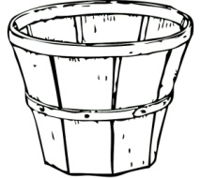 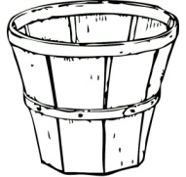 = __________

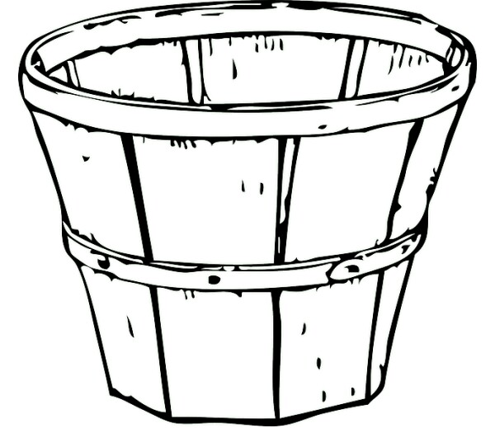

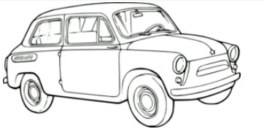 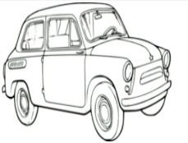 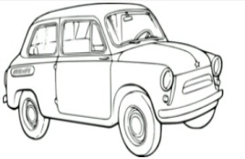 = __________________



 = __________________



1. Count and match correctly

**2**

**3**

**4**

**1**

1. Fill in the missing numbers

**1 _____ 3 ______ 5 ____ 7 . ______ 9 _______.**

**PATFIN NURSERY AND PRIMARY SCHOOL, AKESAN, LAGOS STATE.**

**THIRD TERM EXAMINATION [ 2017 / 2018 ]**

**CLASS : HEAD – START**

**NAME : __________________________________________ SUBJECT: LETTER – WORK**

**INSTRUCTION : ANSWER CORRECTLY DURATION : 1 HOUR**

1. Trace letter A
2. Write letters **A --- F**

__________ ___________ __________

_________ _________ _________

1. Fill in the gaps

***A _____ C ______ E _______***

1. Touch and circle letter **C**

**A B**

**D E F**

**G C**

1. Match objects to letters

**A**

**B** 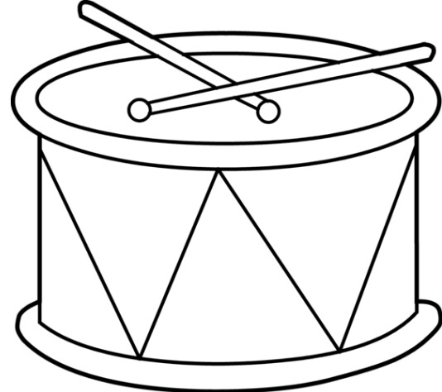

**C **

**D **

**E **

**PATFIN NURSERY AND PRIMARY SCHOOL, AKESAN, LAGOS STATE.**

**SECOND TERM EXAMINATION**

**CLASS : HEAD – START**

**NAME : __________________________________________ SUBJECT: SHAPES AND COLOURS**

**INSTRUCTION : IDENTIFY THESE ITEMS DURATION : 1 HOUR**

1. Colour the shape Blue .

What shape is this ? It is a ______________________________

1. Colour the shape Yellow

What shape is this ? It is a ______________________________

1. Color the Flower

What shape is this ? It is a ______________

1. Colour the shape Yellow .

What shape is this ? It is a ______________________________

1. Colour the shape Red

What shape is this ? It is a ______________________________

**PATFIN NURSERY AND PRIMARY SCHOOL, AKESAN, LAGOS STATE.**

**THIRD TERM EXAMINATION [ 2017 / 2018 ]**

**CLASS : HEAD – START**

**NAME : ______________________________________________ SUBJECT: HAND WRITING**

**INSTRUCTION : Write Carefully DURATION : 1 HOUR**

C C C C